**Lesson 4**

**The Business of being a scenic artist**

<https://utvu.co.uk/bectus-success-copy>

<https://bectu.org.uk/topic/contracts/>

<https://bectu.org.uk/article/what-constitutes-a-contract/>

<https://bectu.org.uk/topic/pensions-and-retirement/>

<https://www.bectuartdepartment.co.uk/rate-card-2023>

Current rates

These rates are for the National Living Wage (for those aged 21 and over) and the National Minimum Wage (for those of at least school leaving age). The rates change on 1 April every year. 2

1 and over/ 18 to 20 /Under 18 /Apprentice April 2024

£11.44 £8.60 £6.40 £6.40

Over 21 £429 for 37.5 week 18-20 £322.50 under 18 £240

<https://www.creativelivesinprogress.com/article/resources-creative-unions>

<https://bectu.org.uk/bectu-extra-membership-public-liability-and-personal-accident-insurance-2024/>

<https://www.gov.uk/national-insurance/how-much-you-pay>

<https://caseron.co.uk/work-from-home-allowance-calculator/>

<https://www.gov.uk/working-for-yourself>

https://www.gov.uk/late-commercial-payments-interest-debt-recovery/charging-interest-commercial-debt

We will exercise our statutory right to claim interest (at 8% over the Bank of England base rate) and compensation for debt recovery costs under the Late Payment legislation if we are not paid according to our agreed terms.

<https://www.contractorcalculator.co.uk/late_payment_calculator.aspx>

<https://www.scenicassociation.co.uk/>

<https://www.scenicguild.org/>

<https://www.linkedin.com/feed/>

<https://www.flints.co.uk/>

<https://www.peterevansstudios.co.uk/>

<https://www.facebook.com/groups/934284610033248>

The watchlist

<https://tvwatercooler.org/>

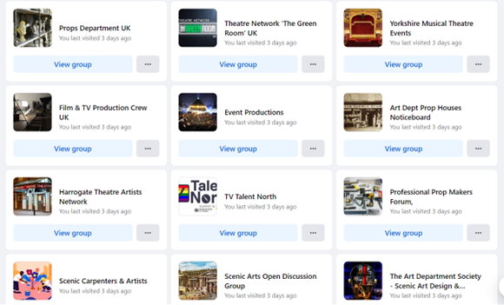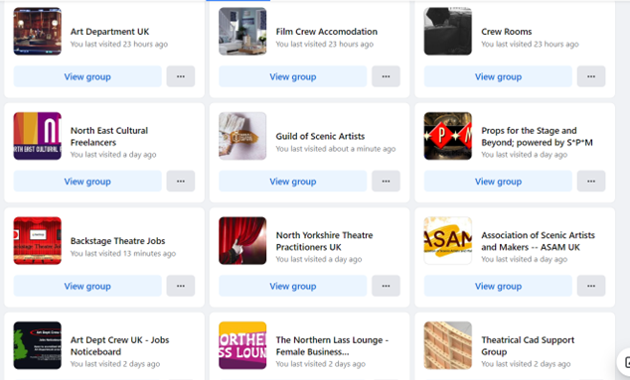

•https://theatregreenbook.com/

https://theatregreenbook.com/sustainableproductions-toolkit/scenic-art/

https://www.gov.uk/working-for-yourself

https://taylortheatrics.com/2018/02/02/2018-02-02-must-haves-scenic-painting/

https://www.1stformations.co.uk/blog/working-from-home-7-expenses-you-should-be-claiming/

https://caseron.co.uk/work-from-home-allowance-calculator/

https://www.production-hive.co.uk/magazine

https://www.screenskills.com/online-learning/learning-modules/how-to-apply-for-work-in-the-screen-industries/

<https://www.screenskills.com/>

https://www.facebook.com/groups/428917397284763/

https://www.crewrooms.uk/

https://www.facebook.com/groups/716652055074267/

https://www.comfyworkers.com/en/industry/film-media-crew-accommodation

<https://londontheatredigs.com/index.php/london-film-crew-digs/>

https://spectrum.rosco.com/index.php/2019/12/how-to-make-a-large-scale-wood-graining-tool

https://spectrum.rosco.com/

https://taylortheatrics.com/2018/07/18/prop-making-must-haves/

https://www.scenicpainters.com/ • https://www.youtube.com/@SetDesignChannel

https://www.scenicassociation.co.uk/training

•https://www.youtube.com/playlist?list=PL39C7B0CCE67102E3 national theatre

<https://www.youtube.com/watch?v=uy8SiWGPI1I>

Online books pdfs.

https://api.pageplace.de/preview/DT0400.9781317384380_A28765194/preview-9781317384380_A28765194.pdf The craft and art of scenic design

https://booksite.elsevier.com/samplechapters/9780240804620/9780240804620.PDF Part one The Professional scenic artist

https://portal.rcs.ac.uk/production/wp-content/uploads/sites/433/2016/11/Scenic-Art-Handbook.pdf Scenic art dept handbook

https://www.oldvic.ac.uk/wp-content/uploads/2019/06/Scenic-Art-Equipment-List.pdf Scenic art equipment list

Tiktok creators to follow

<https://www.tiktok.com/@imaginetheatre>

https://www.tiktok.com/@jomopm – production manager <https://www.tiktok.com/@trin.paints.signs>

<https://www.tiktok.com/@rachelemillar>

<https://www.tiktok.com/@unproductivebrothers>

<https://www.tiktok.com/@lyricsceneshop>

<https://www.tiktok.com/@meredithwolting>

<https://www.tiktok.com/@maggiekearnan>

<https://www.tiktok.com/@yesterdayspresent>

<https://www.tiktok.com/@ecctheatre>

<https://www.tiktok.com/@smiley__clown>

<https://www.tiktok.com/@itschristiegayle>

<https://www.tiktok.com/@artbywarsh>

Useful Youtube channels

Behind the Scenics - https://www.youtube.com/channel/UCCDp3ek1KsyJQtq8u2lb2dQ

https://www.youtube.com/@Iliketomakestuff – props

https://www.youtube.com/@TheBigTiny – couple of set building videos

https://www.youtube.com/@AdenHynesSculptureStudios – sculpture work

https://www.youtube.com/@belgradetheatre – has videos from panto designers

https://www.youtube.com/@HollywoodHaunter – hardcoating techniques

https://www.youtube.com/@VanOaksProps – scenic techniques

https://www.youtube.com/@StiltbeastStudios – promaking on the cheap

https://www.youtube.com/@theunemployedpropguy3188 – scenic techniques

https://www.youtube.com/@smoothon – product information

https://www.youtube.com/@FlintsTheatricalChandlers – flints own youtube

<https://www.acas.org.uk/non-disclosure-agreements>

GDPR Statement - This document may be kept on file and distributed for employment purposes