Lesson 6 Techniques, Methods and Tips

Moss, (division Bryophyta), any of at least 12,000 species of small nonvascular spore-bearing land plants. Mosses are distributed throughout the world except in salt water and are commonly found in moist shady locations. They are best known for those species that carpet woodland and forest floors. Ecologically, mosses break down exposed substrata, releasing nutrients for the use of more-complex plants that succeed them. They also aid in soil erosion control by providing surface cover and absorbing water, and they are important in the nutrient and water economy of some vegetation types. Economically important species are those in the genus Sphagnum that form peat. See also bryophyte and list of mosses.
Sporophyte Young sporophyte of tortula moss (Tortula muralis). Mosses existed as early as the Permian Period (298.9 million to 251.9 million years ago), and more than 100 species have been identified from fossils of the Paleogene and Neogene periods (66 million to 2.58 million years ago). Muscites, Protosphagnum, Palaeohypnum, and other fossil mosses are similar in structure to modern genera. Extant species include the valvate mosses (subclass Andreaeidae) and peat mosses (family Sphagnaceae). The large subclass Bryidae constitutes most species of mosses, but the subclass Polytrichidae also has some important members. Other, smaller subclasses are represented by only a few species.
A mold or mould is one of the structures that certain fungi can form. The dust-like, colored appearance of molds is due to the formation of spores containing fungal secondary metabolites. The spores are the dispersal units of the fungi. Not all fungi form molds.
Mossy gravestone sample sheet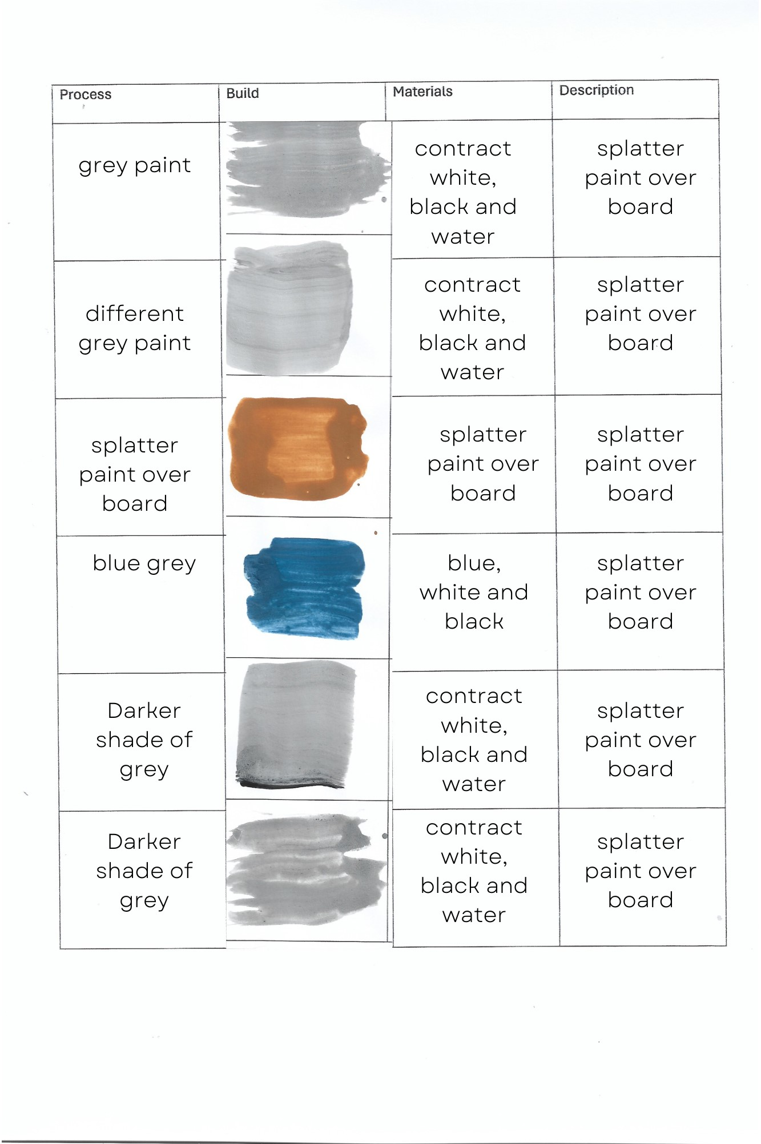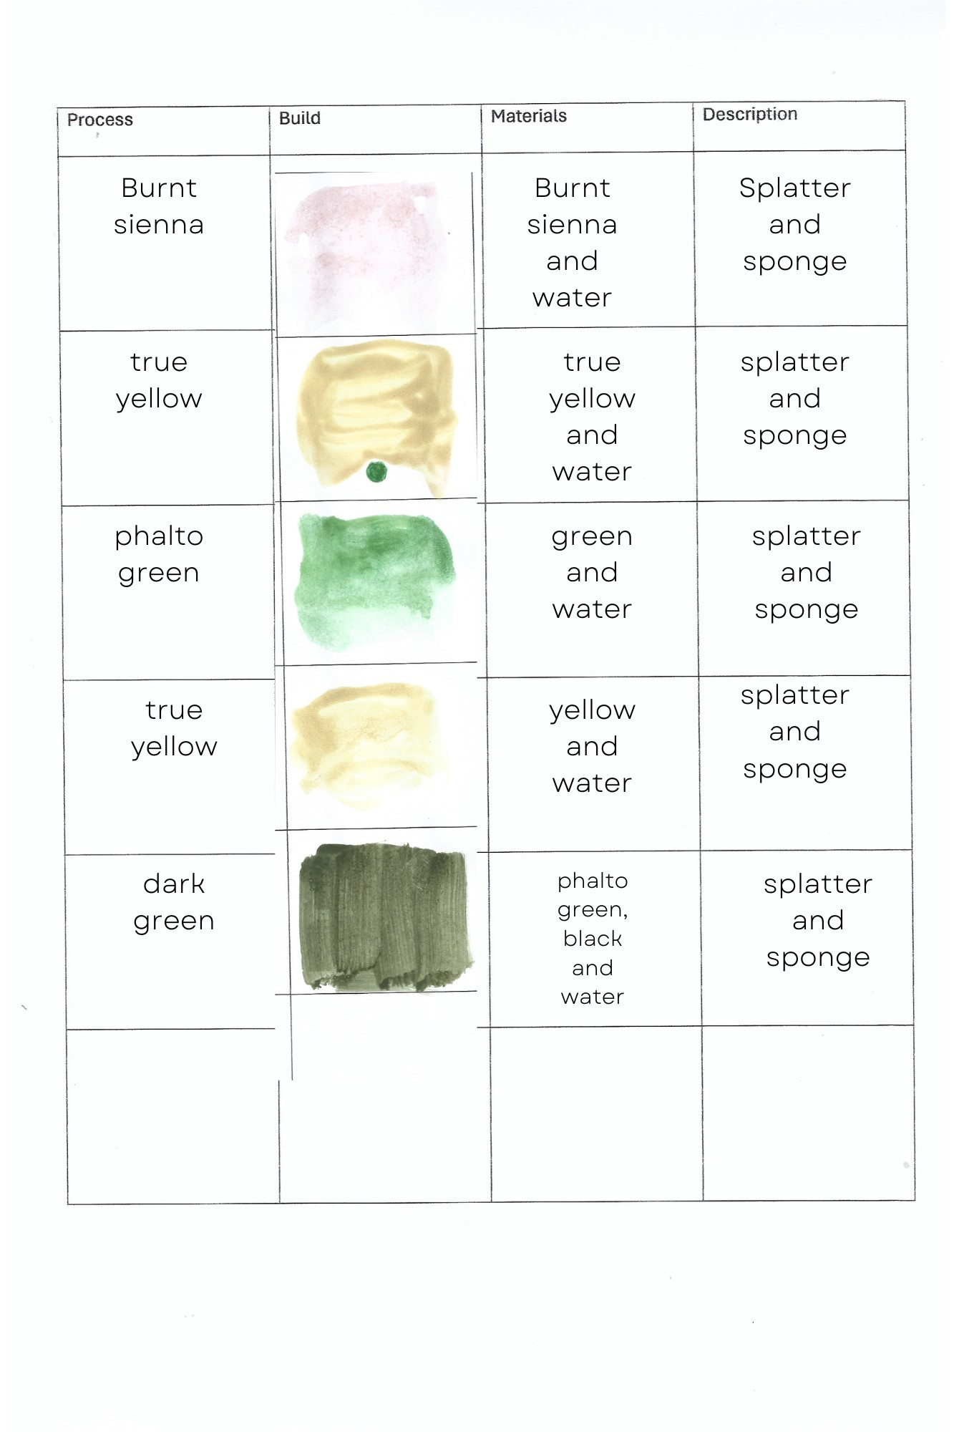
Marble is a metamorphic rock consisting of carbonate minerals that recrystallize under the influence of heat, pressure, and aqueous solutions (most commonly calcite (CaCO₃) or dolomite (CaMg(CO₃)₂) and has a crystalline texture of varying thickness.[1] Marble is typically not foliated (layered), although there are exceptions. In geology, the term marble refers to metamorphosed limestone, but its use in stonemasonry more broadly encompasses unmetamorphosed limestone.[2] Marble is commonly used for sculpture and as a building material.

https://www.youtube.com/watch?v=0h-EbQk10hY – marble techniques video

https://www.amazon.co.uk/Feathers-Colorful-Handmade-Ornament-Decoration/dp/B0B4J2ZBJM/ref=asc_df_B0B4J2ZBJM/?tag=googshopuk-21&linkCode=df0&hvadid=641730381560&hvpos=&hvnetw=g&hvrand=11991525221474011512&hvpone=&hvptwo=&hvqmt=&hvdev=c&hvdvcmdl=&hvlocint=&hvlocphy=1006688&hvtargid=pla-1934107004793&psc=1&mcid=f9e2b1f5c9123dc6a56bfe758ed9d4c3
https://www.goldleafsupplies.co.uk/swan-feathers-for-marbling-6671/
https://www.amazon.co.uk/Natural-Sea-Sponges-Artists-Unbleached/dp/B07BDQ34R9
https://www.screwfix.com/p/energer-enb769srg-700w-electric-spray-gun-240v/497kj - This is the link to my sprayer it has increased in price since I purchased it last year.
https://www.peterevansstudios.co.uk/brick-walls/

